**Date: 28-10-2021**



**SOFTWARE DESIGN AND ARCHITECTURE**

**LAB NO. 05**

**Domain Model**

**Submitted by:**

Hajra Muqddsa Akbar

Roll no. 12319

Maheen Nasir

Roll no. 12315

**Course and Section:**

BSSE--4B

**Submitted To:**

Madam Saadia Shabir

Q1 **Consider a school management system. Draw a domain model for this scenario and identify conceptual classes by using following conceptual class category list i.e taught in lecture**

|  |  |
| --- | --- |
| Business Transaction |  |
| Transaction line item |  |
| Product or service |  |
| Where is transaction recorded |  |
| Roles of people or organization |  |
| Noteworthy events, often with a place or time we need to remember |  |
| Physical objects |  |
| Description of things |  |
| Catalog |  |
| Container of things (physical or informational) |  |
| Things in container |  |
| Other collaborating system |  |
| Record of finance, work, contract, legal matters |  |
| Financial instrument |  |

Diagram:

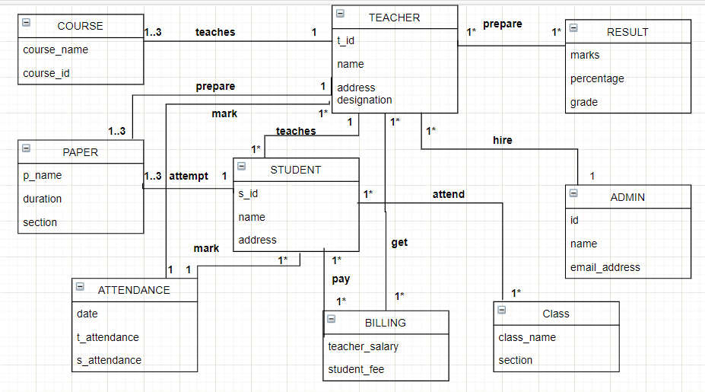

Q2 Consider the following use case and develop a Domain Modelusing a noun phrase identification technique to represent therelevant conceptual classes with attributes and the associationbetween them

Title: Deposit Money in ATM  
Primary Actor: Customer  
Main Scenario: The Customer approaches the Bank's ATM  
The customer inserts his/her card  
The ATM requests the customer's PIN  
The customer enters his/her PIN  
The ATM validates the customer's details  
The ATM displays a list of actions  
The customer selects deposit  
The ATM requests the money be inserted  
The customer inserts the money in the ATM  
The ATM adds up the money inserted and asks customer to confirm total  
The customer confirms the total  
The ATM updates the balance of the customer's selected account  
The ATM returns the customer's card.

**Nouns:**

Money, customer, bank, ATM, atm card, balance, account.

**Diagram:**

